STRATEGIC THINKING
Week 1: Introduction to Strategic Thinking
Student Handbook

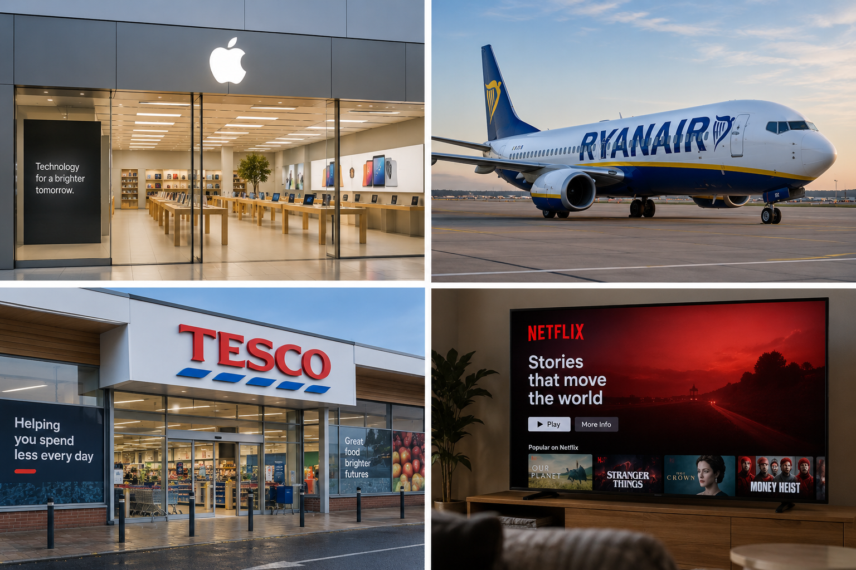

This week: understand how goals, strategic thinking and strategy connect; distinguish strategic and operational decisions; explore levels of strategy; and see how data supports better decisions.

1. Start with the big picture
Businesses make hundreds of decisions. Some decisions solve today's problems. Others shape where the organisation will be in several years. Strategic thinking is concerned with the second type - but it begins with a clear goal.

Goal, strategic thinking and strategy
Concept | Meaning | Simple question
Goal | The result the organisation wants to achieve. | Where do we want to go?
Strategic thinking | The process of examining the situation, evidence, options, risks and future possibilities before choosing a direction. | What should we do, and why?
Strategy | The overall approach chosen to achieve the goal. | How will we get there?
GOAL -> STRATEGIC THINKING -> STRATEGY -> ACTION -> RESULT

Example: an online retailer
Goal: Increase online sales by 25% over the next two years.
Strategic thinking: Examine customer behaviour, competitors, delivery costs, technology, market trends, available resources and alternative ways to grow.
Strategy: Improve mobile ordering, introduce more personalised offers and expand same-day delivery in selected locations.
Actions: Develop the service, assign resources, launch the changes and monitor performance.
Results: Measure sales growth, customer retention, delivery performance and profitability.
Important: strategic thinking is not simply “having a strategy”. It is the reasoning process used to decide whether a strategy makes sense.

2. Check your understanding: Goal or strategy?
Before answering, remember: a goal describes the desired result. A strategy describes the chosen approach for reaching that result.

Worked example
Statement: “A company wants to reduce customer waiting time by 30%.”
This is a goal because it describes the result the company wants to achieve. It does not yet explain how the company will achieve it.
Statement: “The company will introduce online appointment booking and redesign staff scheduling.”
This is a strategy because it describes the approach chosen to achieve the desired result.

Now check
A. “Increase customer retention over the next three years.”
B. “Use personalised recommendations and a redesigned loyalty programme to improve retention.”
Which is the goal and which is the strategy? Enter your answer in the online chat when asked.
CHECK YOUR ANSWER
A = Goal. B = Strategy. A states the desired outcome; B states an approach for reaching it.

A third statement
C. “Analyse customer behaviour, competitor offers, reasons for cancellation, costs and several possible retention approaches before choosing what to implement.”
What does C represent?
CHECK YOUR ANSWER
C = Strategic thinking. The company is analysing the situation and alternatives before deciding its strategy.

More examples: Goal → Strategic Thinking → Strategy
Company / situation | Example | Why it fits
Ryanair | Goal: increase passenger demand on selected routes. Strategic thinking: examine demand, competitors, airport costs and traveller behaviour. Strategy: adjust the route network and pricing approach based on the evidence. | The goal is the desired result; strategic thinking compares evidence and options; the strategy is the chosen direction.
Tesco | Goal: grow online grocery sales. Strategic thinking: study customer location, basket size, delivery cost, competitor services and capacity. Strategy: expand delivery selectively and improve the online shopping experience. | The three stages show what the business wants, how it reasons, and what approach it chooses.
Netflix | Goal: improve customer retention. Strategic thinking: analyse cancellations, viewing patterns, pricing, competitors and content preferences. Strategy: improve content discovery and make targeted content investments. | The strategy follows analysis rather than being an immediate reaction.
Small coffee chain | Goal: increase repeat customers. Strategic thinking: compare a loyalty app, price changes, new products and faster service using customer and cost data. Strategy: introduce a digital loyalty programme if the evidence supports it. | Strategic thinking considers alternatives and trade-offs before committing resources.
Quick check: A college wants to increase student retention. It first examines attendance patterns, student feedback, support usage and possible interventions. Is this a goal, strategy or strategic thinking? Answer: strategic thinking, because the organisation is analysing the situation and options before choosing an approach.

3. What is strategic thinking?
Strategic thinking is a way of looking beyond an immediate task. It considers the organisation's current position, future direction, external changes, available evidence and the consequences of different choices.

A strategic thinker asks
- What are we trying to achieve?
- What is changing around us?
- What do customers or stakeholders need?
- What does the evidence or data tell us?
- What options are available?
- What are the risks and trade-offs?
- What could happen in the future?
- What would make us change direction?

Example: Netflix
Suppose the goal is to improve customer retention. Immediately producing more content is not yet strategic thinking. The organisation would first need to examine viewing behaviour, reasons for cancellation, competitors, pricing, content preferences, costs and different possible responses. After that analysis, it can choose a strategy.

Online check
A manager says: “Our competitor reduced its price yesterday. We should immediately reduce ours too.”
What information would you want before agreeing with this decision? Write one factor in the online chat.
CHECK YOUR ANSWER
Possible factors include customer price sensitivity, competitor positioning, profit margin, customer churn, product differences, long-term brand position and whether the competitor change is temporary. There can be several reasonable answers.

4. Strategic decisions and operational decisions
Not every important decision is strategic. Strategic and operational decisions operate at different levels of time and purpose.
Feature | Strategic decision | Operational decision
Focus | Long-term direction | Day-to-day delivery
Time horizon | Usually longer term | Usually immediate or short term
Impact | Can affect the whole organisation or a major area | Usually affects ongoing activities
Example | Enter a new market | Schedule staff for tomorrow

Worked example: Ryanair
Opening a substantial set of routes in a new geographic market is mainly strategic because it can affect long-term growth, investment, competition and resource allocation.
Changing the crew assignment for tomorrow's flight is operational because it supports the daily running of the existing business.

Now check
1. Tesco decides to invest in a new digital retail format over the next five years.
2. A store manager changes tomorrow's staff rota.
Which is mainly strategic and which is operational?
CHECK YOUR ANSWER
1 = Strategic. It concerns long-term direction and significant investment. 2 = Operational. It concerns the day-to-day running of the store.

More examples: Strategic vs operational decisions
Company / situation | Example | Why it fits
Apple-style technology company | Strategic: enter a new product category. | Operational: adjust next week’s retail staff schedule.
Airline | Strategic: establish a new base in another country. | Operational: change today’s boarding gate after a disruption.
Supermarket | Strategic: invest in a new digital retail model. | Operational: reorder stock for the weekend.
Streaming service | Strategic: change the long-term subscription model. | Operational: resolve a temporary service incident.
Notice the pattern: strategic decisions shape direction and resource commitment over a longer period. Operational decisions help the organisation run its existing activities effectively.

5. Levels of strategy
Strategy can be considered at different levels of an organisation. The exact structure varies between organisations, but three common levels are corporate, business and functional strategy.

Corporate level
Concerned with the overall direction and scope of the organisation. Example: Should a company enter a new country, acquire another business, or move into a new industry?

Business level
Concerned with how a business or business unit competes in a particular market. Example: Should it compete mainly through lower cost, differentiated service, convenience or another source of value?

Functional level
Concerned with how functions such as marketing, operations, HR, finance, IT or analytics support the broader strategy. Example: How should the marketing team use customer data to improve engagement?

Worked example: a supermarket group
Corporate: decide whether to expand into another country. Business: decide how the supermarket brand will compete in that market. Functional: decide how marketing, supply chain and analytics teams will support that approach.

Online check
A company decides to enter a completely new industry. Which level is this mainly associated with?
CHECK YOUR ANSWER
Corporate level, because the decision changes the overall scope and direction of the organisation.

6. Strategy involves choices and trade-offs
Organisations rarely have unlimited money, time, people or technology. Choosing one direction can mean giving up another. This is why strategy involves trade-offs.

Example
A retailer has limited investment available. It could open more physical stores, improve its online platform, reduce prices, or invest in faster delivery. It may not be able to do all four at the same time.
Strategic thinking helps the organisation compare these options against its goal, resources, customers, competitors, evidence and risks.

Online question
Imagine a small coffee chain wants to grow. It can afford only one major investment this year:
- Open two new stores
- Build a strong mobile ordering and loyalty app
- Reduce prices across the menu
Choose one option and write one reason in the online chat. There is no single correct answer: the quality of the reasoning matters.

What would strengthen the decision?
Useful evidence could include customer location, order patterns, queue times, repeat purchases, competitor prices, delivery demand, store profitability and the cost of each option.

More examples: Three levels of strategy
Company / situation | Example | Why it fits
Retail group | Corporate: enter a new country. | Business: decide how the retail brand will compete there. Functional: marketing uses loyalty data to support that approach.
Airline group | Corporate: acquire or create another airline business. | Business: decide how a particular airline competes on price and routes. Functional: operations redesign turnaround processes.
Technology company | Corporate: move into a new business area. | Business: decide how a product line differentiates itself. Functional: the analytics team designs measures to track adoption.
Streaming company | Corporate: expand into another entertainment category. | Business: decide how the streaming service competes for subscribers. Functional: product teams improve content discovery.
Online self-check: “The marketing team changes how it uses customer data to support the company’s growth strategy.” This is mainly functional-level strategy because a specific function is supporting the wider business direction.

7. The role of data in strategic thinking
Data does not make the decision by itself. It provides evidence that can help managers understand a problem, compare options, test assumptions and monitor results.

Example: Tesco
If a retailer is considering expanding online delivery, useful data could include where online orders originate, average basket value, delivery costs, demand by time and location, repeat purchase behaviour and customer feedback.
The strategic question is not simply “What data do we have?” It is “What decision are we trying to make, and what evidence would help us make it?”

Worked example
Decision: Should a retailer extend same-day delivery to another area?
- Possible evidence: demand in the area
- Order value and frequency
- Distance and delivery cost
- Existing competitor services
- Customer feedback
- Expected capacity and staffing needs

Online check
A streaming company notices that many customers stop using the service after two months. Name one piece of data that could help the company understand why.
CHECK YOUR ANSWER
Examples include viewing frequency, completion rates, search behaviour, content availability, cancellation reasons, customer support interactions or pricing changes. The useful data depends on the question being investigated.

More examples: Matching data to a strategic question
Company / situation | Example | Why it fits
Coffee chain: Where should we open next? | Potential evidence | Customer locations, footfall, rent, nearby competitors, current store performance and local demand.
Airline: Should we add a new route? | Potential evidence | Passenger demand, airport charges, competitor routes, seasonality, expected fares and aircraft capacity.
Streaming service: Why are customers cancelling? | Potential evidence | Cancellation timing, viewing frequency, content engagement, price-plan changes, support issues and customer feedback.
Supermarket: Should same-day delivery expand? | Potential evidence | Order density, basket value, delivery cost, staffing capacity, customer demand and competitor coverage.
The useful data depends on the decision. Collecting more data is not automatically better; the evidence should help answer the strategic question.

8. Bringing the ideas together
The concepts from Week 1 connect. A business begins with a desired outcome, thinks strategically about its situation and choices, selects a strategy, turns it into actions and then evaluates the results.
GOAL
Where do we want to go?
STRATEGIC THINKING
What is happening? What evidence do we have? What options, risks and trade-offs should we consider?
STRATEGY
What overall approach will we take?
ACTION
What will we actually do?
RESULT
What happened, and what should we learn?

Example: Netflix-style streaming business
Goal: improve customer retention. Strategic thinking: examine viewing behaviour, cancellations, competitors, pricing, content preferences and alternative responses. Strategy: choose a coherent approach, such as improving content discovery and investing selectively in content that supports retention. Actions: implement the chosen changes. Results: monitor retention and related performance measures.

Important feedback loop
The process is not always one-way. New evidence, unexpected results or changes in the business environment may require the organisation to rethink its strategy - and sometimes reconsider the goal itself.

9. Individual online activity: You are the strategy analyst
Choose one familiar organisation. You may use Apple, Ryanair, Tesco, Netflix or another organisation you know reasonably well.
- State one clear goal the organisation could pursue.
- Identify one current challenge or opportunity related to that goal.
- List three pieces of information or data that would help you understand the situation.
- Identify two possible strategic options.
- State one risk or trade-off for each option.
- Choose one strategy and explain your reasoning in 2-3 sentences.
- Give two actions that could help implement the strategy.
- Suggest one result or measure that would help determine whether the strategy is working.
Your answer does not need to match another student's answer. Strategic problems can have more than one reasonable solution. Focus on making the connection between the goal, evidence, options and chosen strategy.

Response space
Organisation:
________________________________________________________________________________
Goal:
________________________________________________________________________________
Challenge/opportunity:
________________________________________________________________________________
Useful data:
________________________________________________________________________________
Option 1 + trade-off:
________________________________________________________________________________
Option 2 + trade-off:
________________________________________________________________________________
Chosen strategy + reasoning:
________________________________________________________________________________
Actions:
________________________________________________________________________________
Measure/result:
________________________________________________________________________________

